REVERSE OF DIGIT

DHIVYA SHREE K

230701079

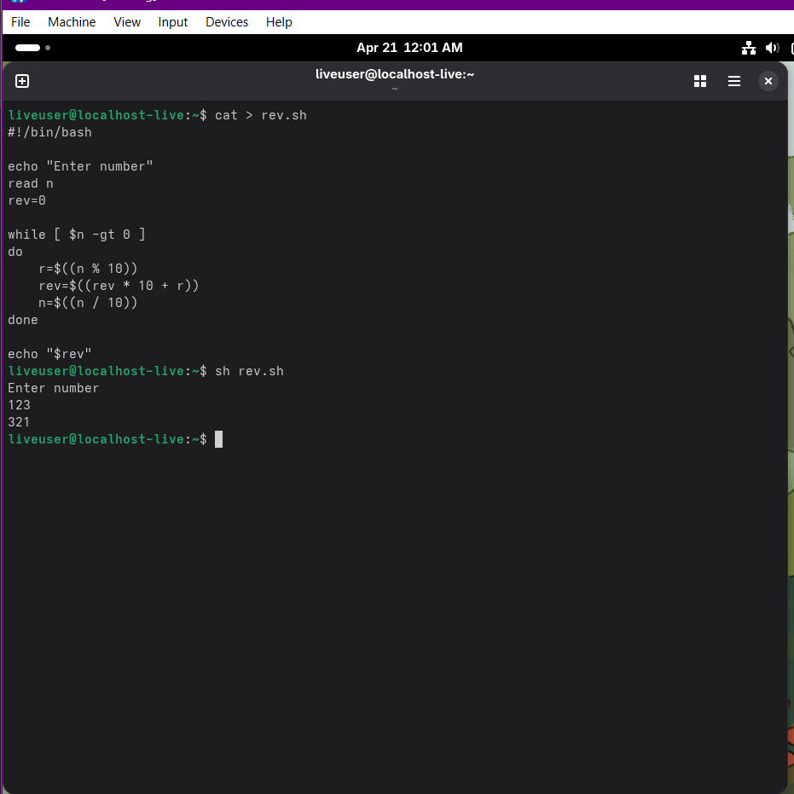

FIBBNONACCI SERIES

